CIM WIRING PINOUT
NI- 9223: FPGA cMODULE
VMON SIGNAL A0 BNC 0
ACCT SIGNAL A1 BNC 1

NI-9401:
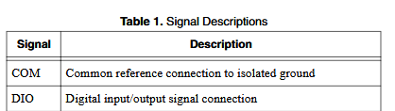
SOURCE-GATE DIO0 PIN 0, COM
CHOPPER-GATE DIO1 PIN 1, COM
*REF to COM pins. REFER TO NI-SPEC SHEET

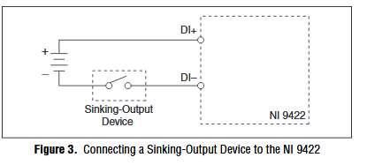
NI- 9422:
CHOPPER_ON DIO0 PIN 0+, PIN 1-
FARADAY_IN DIO1 PIN 2+, PIN 3-
*NEEDS + AND – WIRING. REFER TO NI-SPEC SHEET

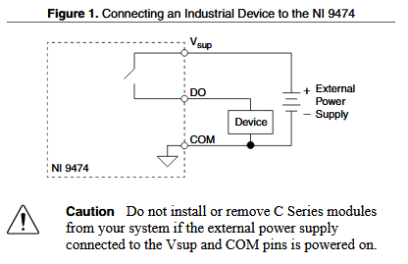
NI-9474:
FBI DIO0 PIN 0
*NEEDS Vsup AND GND WIRING. REFER TO NI-SPEC SHEET

